OA.VA.99

Lost

0008548402027490697

UAT testlost

1121

01011980

371

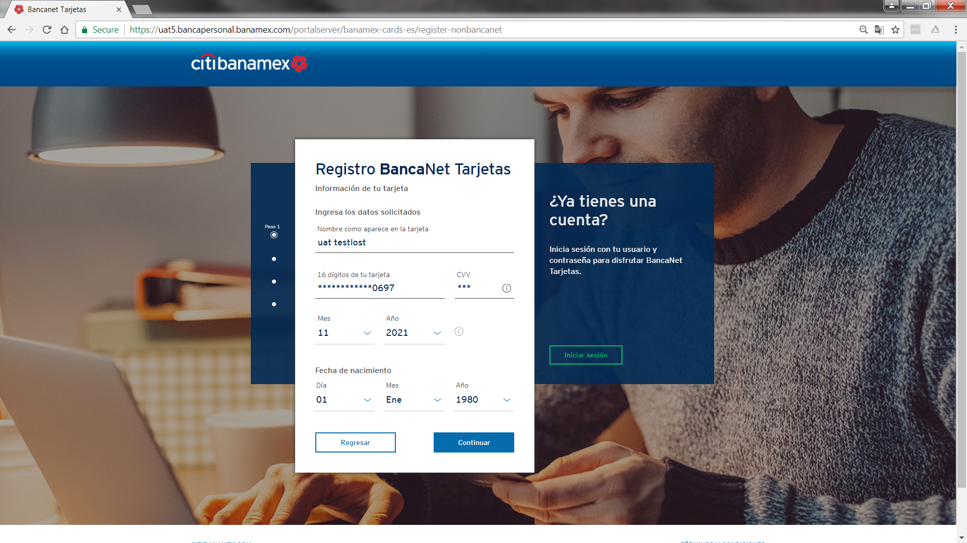

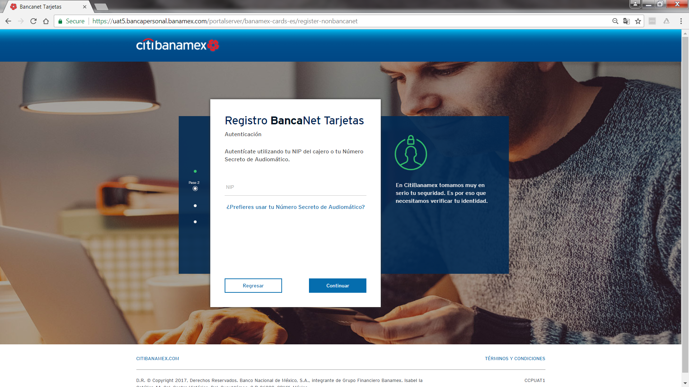

Stolen

0005456319101314591

UAT TESTSTOLEN

0621

01011980

685

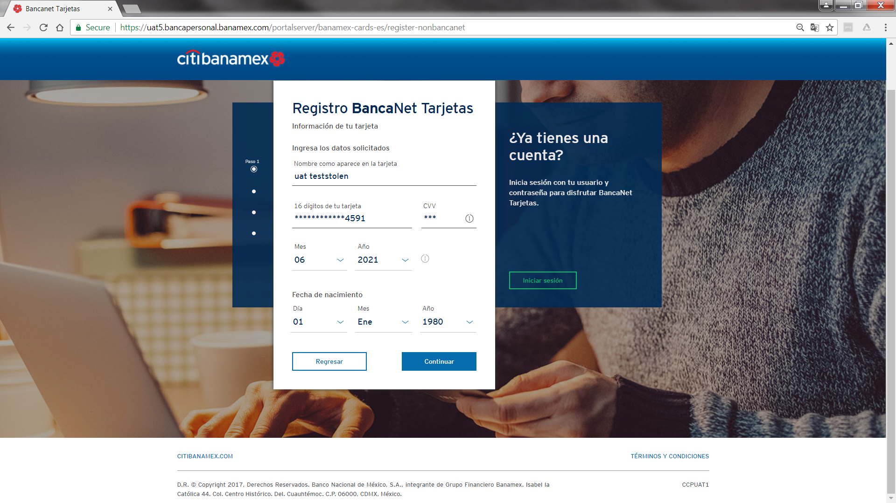

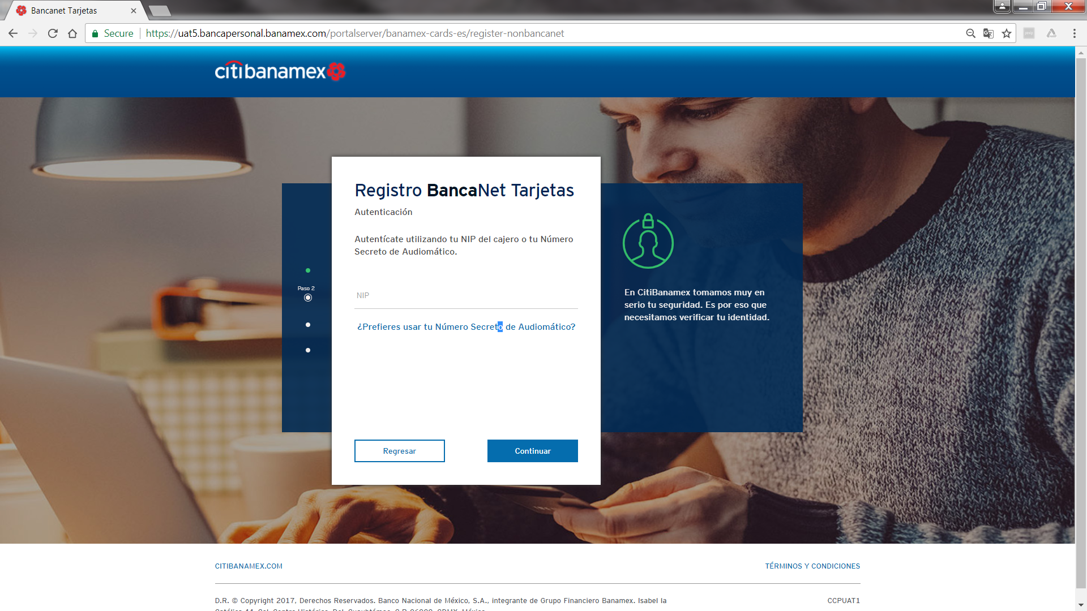

Fraud

0008548409200602485

0822

UAT TESTFR

01011980

976

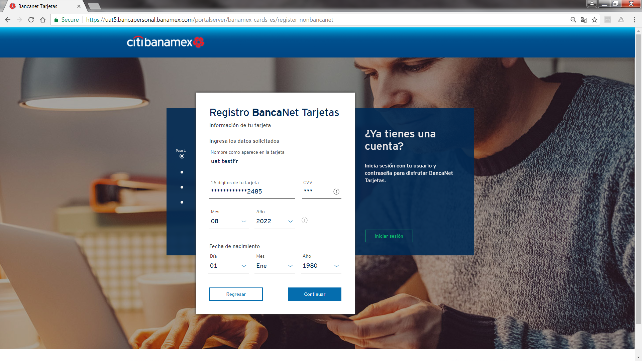

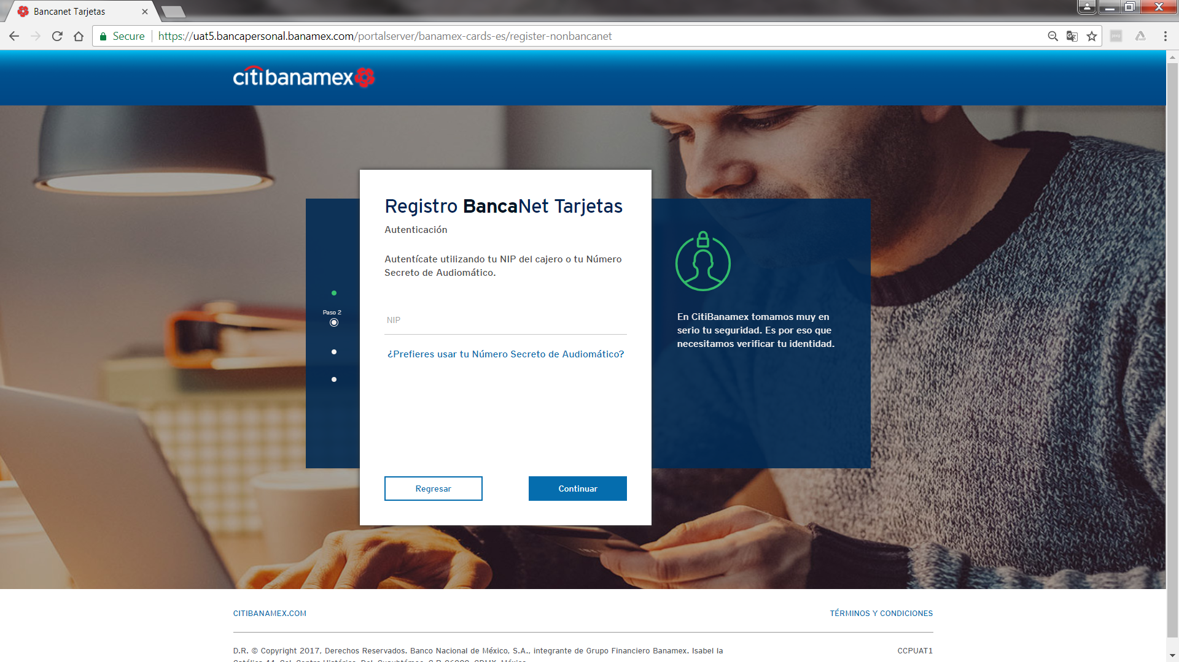

Additional data

Fraud

0004053060000531691 0000000000083993880

4/30/2018

ZXXY ZXZYXYXYYZYZYYY

325-CVV

01011980

Lost

0004053060000537391 0000000000018407801

4/30/2018 XZYZZZYZYXXZZXYYXXXYZ

505 -CVV

01011980

stolen

0004053069032630371 0000000000003917357

6/30/2018 XXXYZZYYYYXXZZZZYY

670-CVV

01011980